EXPNO 4: CREATE A SNAPSHOT AND CLONING OF A VM AND TEST IT BY LOADING THE PREVIOUS VERSION/CLONED VM.

Procedure:

1. Shut down source VM (with snapshots)
2. Create directory with new VM name at target
3. Copy all files from source dir to target dir
4. Iteratively change names of all files to match new VM name.
5. Update VMDK descriptor with new name
6. Update VMX with new names
7. Generate new UUID for new VM
8. Register new VM in inventory

Implimentation:

SNAPSHOT:

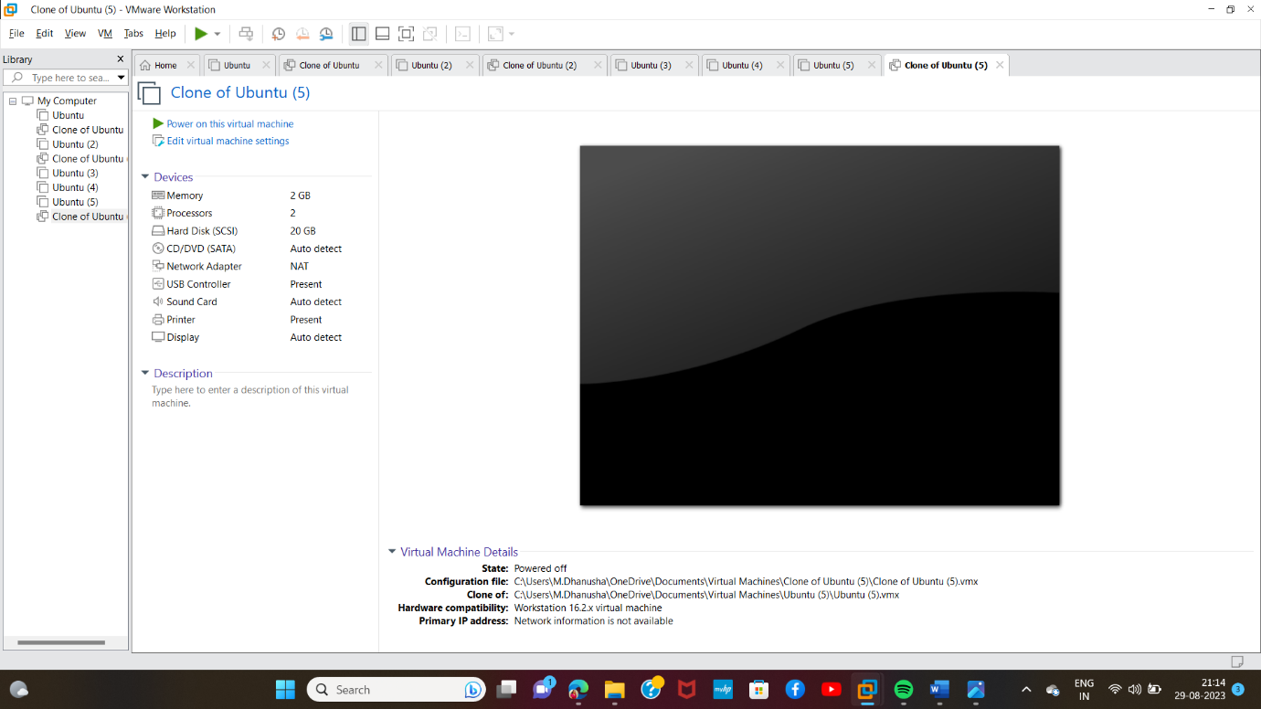

CLONING:

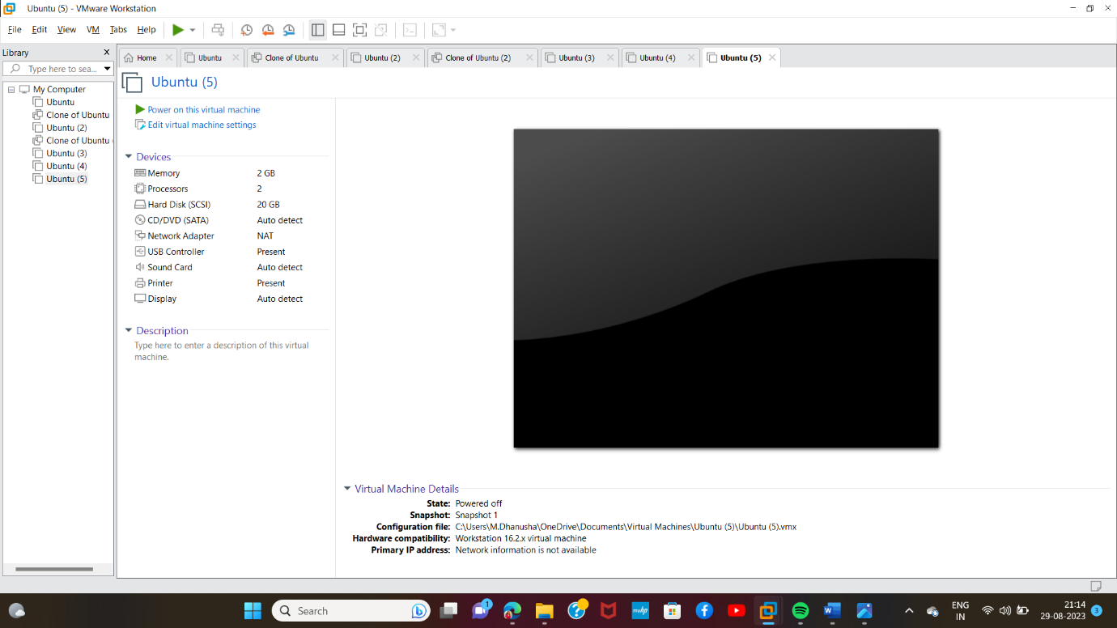

Result: Succsefully implemented Vm Ware.